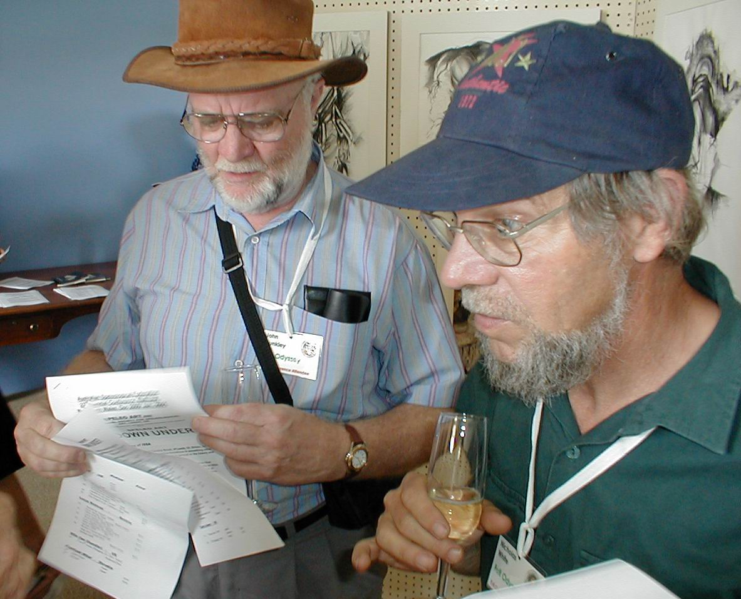
John Dunkley and Nick White at the Art Exhibition

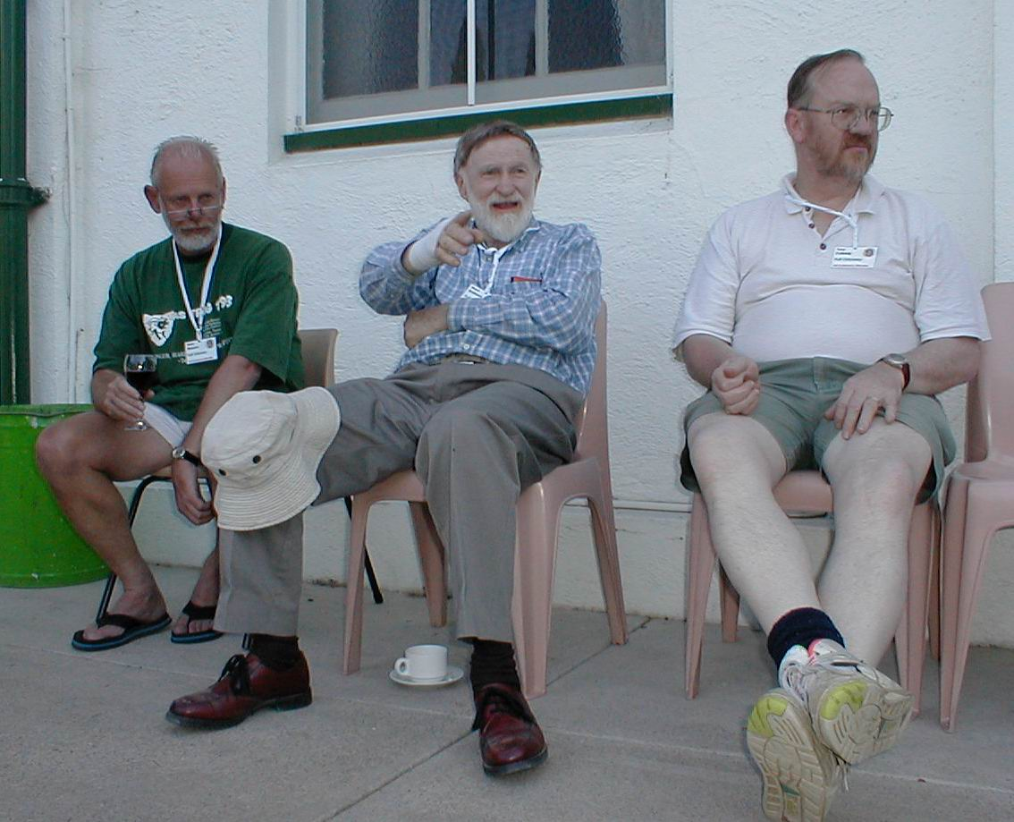
Henry Shannon, Lloyd Robinson and Tony Culberg

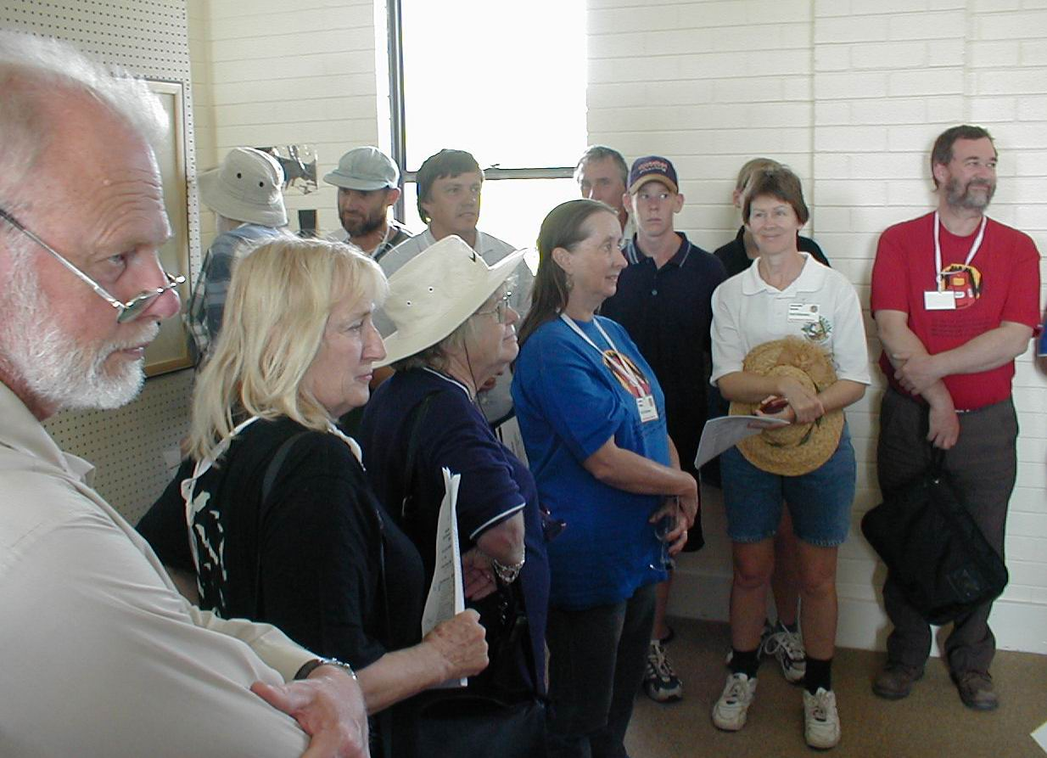
Henry Shannon, June MacLucas, Grace Matts, Sue White, ?, Jeanette Sands, Graham Pilkington at the Art show

Jeff Butt leading a discussion on
Junee-Florentine

all photos on this page taken by Arthur Clarke

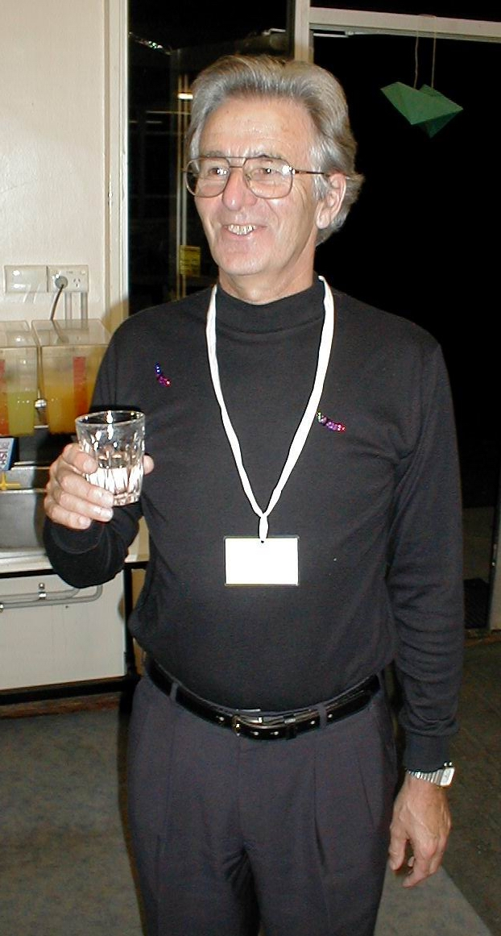
Miles Pierce – Batman

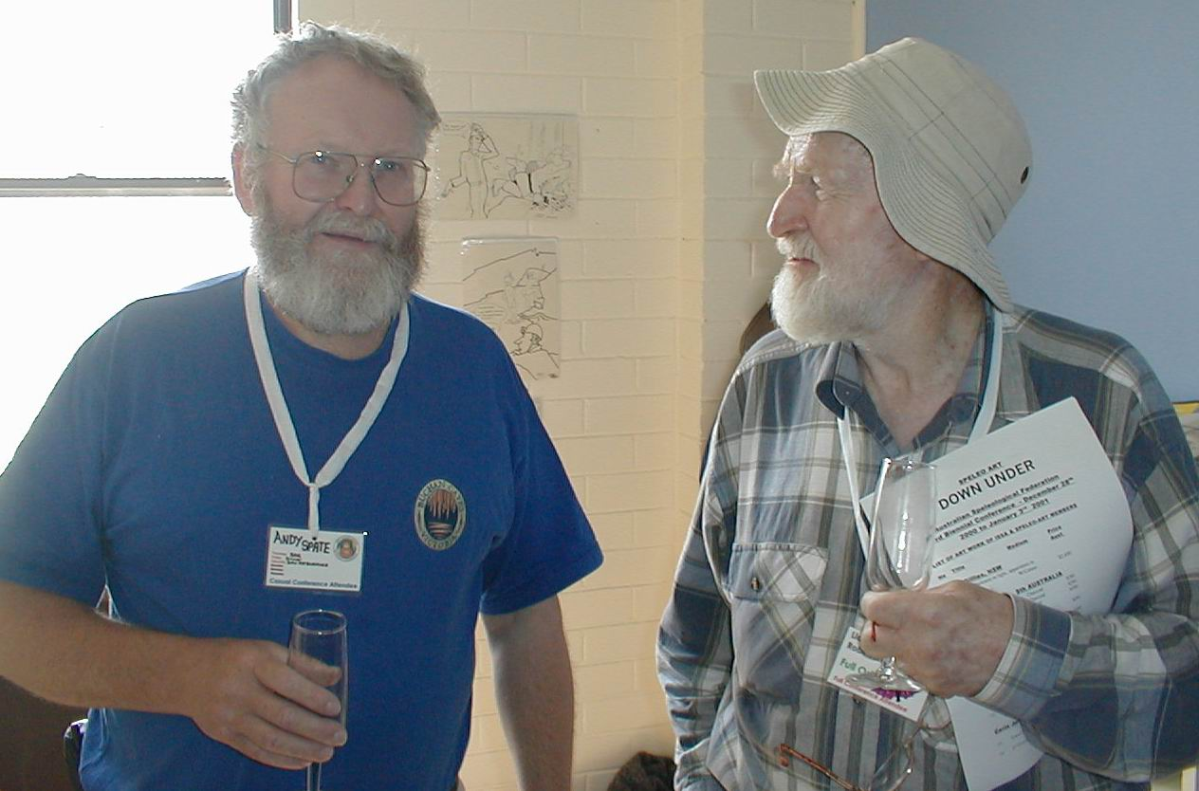
Andy Spate and Lloyd Robinson

